Statistical BeamForming

Assignment 2 : EEL 6935 - SPRING.2018 Hector Lopez 2-17-2018

## Description

## Show that the maximum signal-to-interference-plus-noise ratio (max-SINR), minimum mean-square-error (MMSE), minimum-variance-distortionless-response (MVDR), and maximum likelihood (ML) with Gaussian disturbance beamformers are all equivalent; that is, they are scaled versions of each other.

## Define Statistical Beam Forming Methods

The formulas for each of the beam former methods can be written as the set of equations below. Notice that the R matrix represents the autocorrelation of the receiving signal and the RI+N represents the autocorrelation of the disturbances , interference and noise. The rho is the power of the input signal and the Stheta is the array response vector of the antenna array elements. 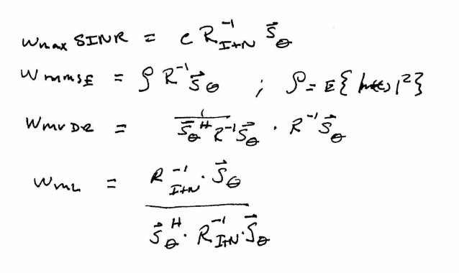

## Understanding the Auto-Correlation Matrix R

Breaking down the R matrix allows us to see the components of the received signal in terms of the desired input equaling the input component.

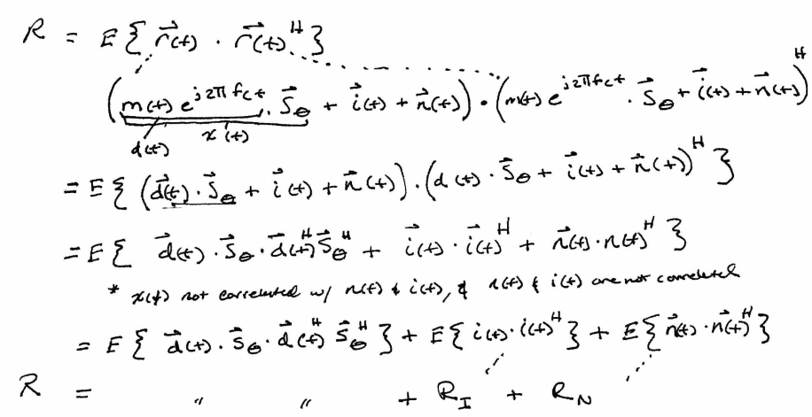

We can group the auto-correlation of the interfence and noise into the following solution for R.

Screen Clipping

We can now take the inverse of both sides and get a similar method that allows us to identify a scalar K between the R and RI+N . With this relationship we can then try to find scalars between the beamformer formulas.

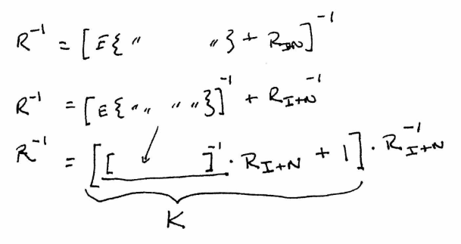

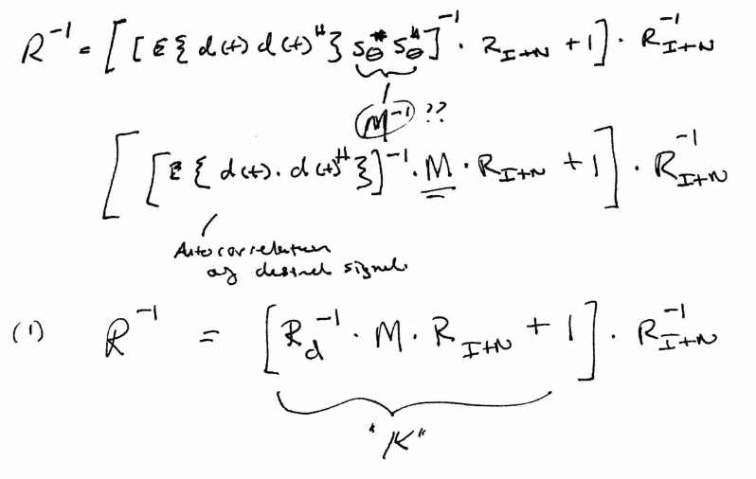

## Solving for Scalars

The combination of the Stheta and Stheta Hermitian is similar the WmaxSNR solution so here we can see that the combination of the array response vectors can be equivalent to the size of the antenna array , or the number of antenna elements M. Notice that the K value in the equation above is used in the following derivations.

Here we define the constant that would set the WmaxSINR equal to the WML:

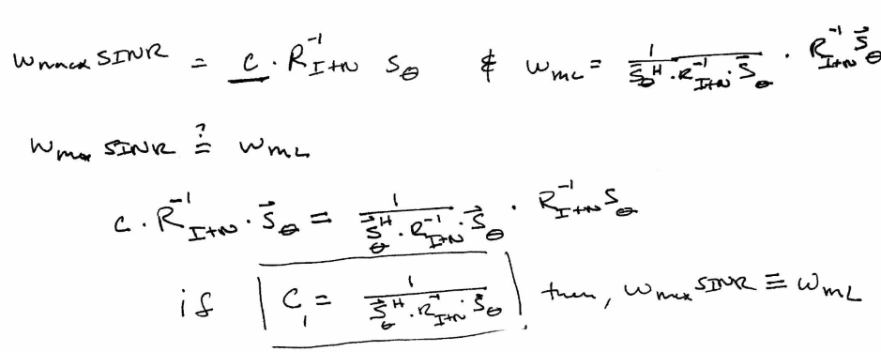

Here we try to find the link between the same WmaxSINR and WMVDR . The use of the K value we defined earlier in equation (1) is needed.

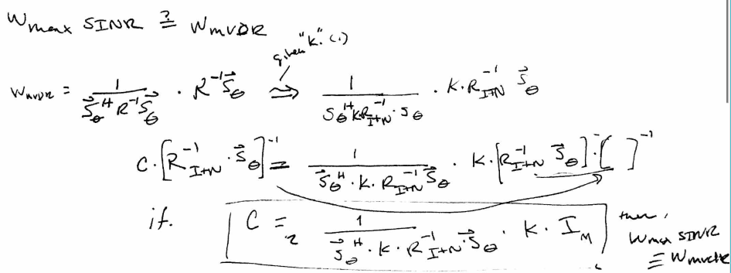

Here we try to find the relationship between the WmaxSINR and the Wmmse . The K is used again by substituting the R-1 / K matrix into the SINR formula. We then see the relationship between the two methods.

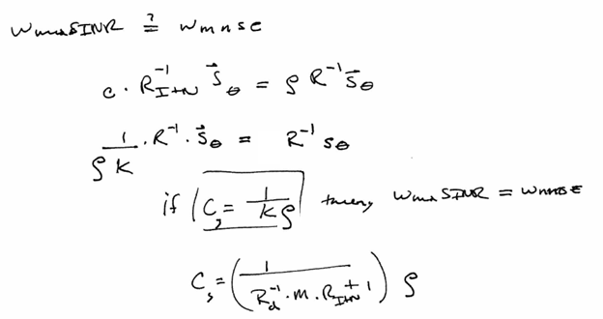

Lets use the constants that we found and try to solve for each equation below.

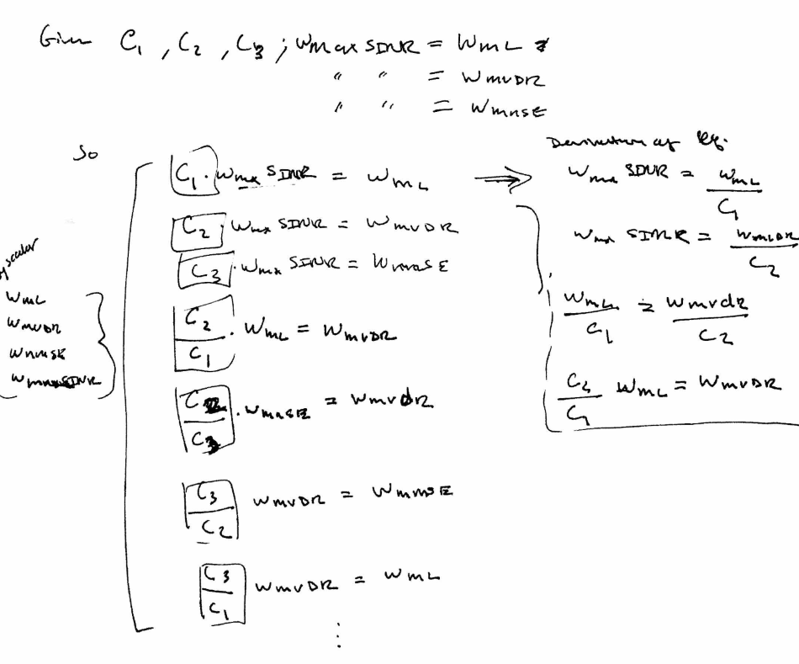

## Conclusion

By finding the constants that relate between the WmaxSINR and the other methods allows us to see that each beam former method can be written as a scalar of the other.